Mega Add-Ons Disney+
1. Launch Details
Key Summary USP | Disney+ is the dedicated streaming home for movies and shows from Disney, Pixar, Marvel, Star Wars, National Geographic and Hulu. Disney+ offers an ever-growing selection of exclusive premieres of originals, including feature-length films, documentaries, live-action and animated series, and short-form content.  As part of the Mega Add-Ons launch, Disney+ is introduced as an entertainment option. Customers can subscribe to the Disney+ streaming service through Mega Add-Ons at a special bundled monthly rate with a 12-month contract.
Channels | - CelcomDigi App  - MSA  - Pulse

2. Product Details
Offering details:
Add-Ons | Disney+ Packages
Package Tier | Basic | Premium
RRP | RM29.90 | RM49.90
CD60 SE – CD100 | RM12.90​ | RM27.90​
CD120 & above | RM3.90 | RM9.90
Contract Period | 12 months
Internet quota | 5GB High speed
Monthly Auto-renewal | Yes
Validity | 30 Days
Monthly cycle | Disney+ Monthly cycle

This service is also available for subscription via StreamMORE / SpeedSTREAM.

3. Eligibility and Criteria
Eligibility & Criteria | - New subscriber (CelcomDigi Postpaid 60 SE and above)  - Existing subscriber (CelcomDigi Postpaid 60 and above)
Termination | - CelcomDigi Store only  Please inform the customer that an early termination penalty will apply. The penalty is calculated as: Recommended Retail Price (RRP) × the number of remaining contract months.

4. Customer Journey
Mega Add-ons Customer Journey | 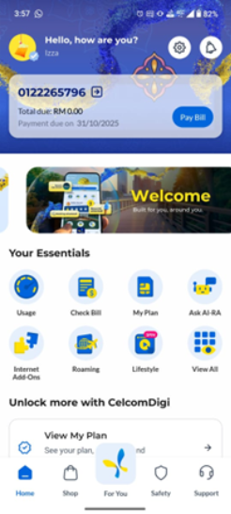 | 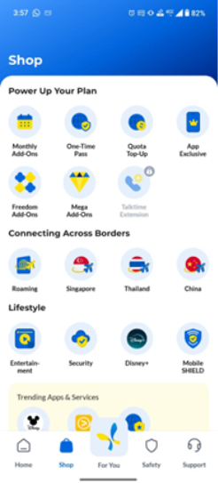 | 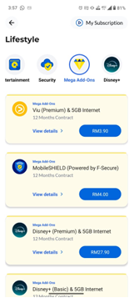
 | Step 1: In the CelcomDigi app, click Shop | Step 2: Click Mega Add-Ons | Step 3: All eligible Entertainment & Security offers will be listed here

5. Customer Communications (Active)
Active Comms | NA
FAQs | https://help.celcomdigi.com/en/support/solutions/articles/70000677098-faq-mega-add-ons-disney-with-celcomdigi-postpaid
Website | https://www.celcomdigi.com/postpaid/mega-add-ons

6. Internal Information

7. Reference Guide (Agent Guide, Scenario Handling and Other References)
Reference Guide

8. Historical Communications (no longer active but retained for reference only)
Inactive Comms | NA
Inactive Customer Journey | NA

